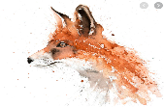

**Class: Foxes Term: Autumn Term [2] 2021 EYFS / Y1 Bears / Celebrations**

**Communication & Language:**

**All pupils will engage in individualised communication therapies, set by SALT, such as Intensive Interaction, Bucket Therapy, Joint Attention and implementation of PECS and BSL. These will have a daily focus with an adult on a 1:1 basis and in pairs or groups.**

*Pupils will be supported to:*

Copy what adults do, taking ‘turns’ in conversations (through babbling) and activities. Try to copy adult speech and lip movements. [Intensive interaction]

Listen and respond to a simple instruction – visual prompts will be used to support where necessary and routines established.

Reach or point to something they want while making sounds.

Understand single words in context – ‘cup’, ‘milk’, ‘daddy’ – use these words verbally, signing or symbols.

Make themselves understood and be supported with frustrations when they cannot.

Show interest to a growing repertoire of songs, rhymes and stories.

**Personal, social and emotional development** *Pupils will be supported to*

Establish their sense of self.

Express preferences and decisions.

They also try new things and start establishing choices, likes and dislikes.

Engage with others through gestures, gaze and talk /signs / symbols.

Play with increasing confidence on their own and with other children, because they know their key person is nearby and available.

Begin to show ‘effortful control’. For example, waiting for a turn.



**Physical Development** *Pupils will be supported to*

Enjoy starting to kick, throw and catch balls.

Build independently with a range of appropriate resources

Develop manipulation and control

Clap and stamp to music from a range of cultures.

Go up steps and stairs, or climb up apparatus, using alternate feet.

Use large-muscle movements to wave flags and streamers, paint and make marks.

Be increasingly independent, as they get dressed and undressed, for example, putting coats on and doing up zips.

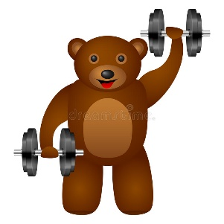

**Literacy** *Pupils will be supported to*

Enjoy songs and rhymes, tuning in and paying attention.

Join in with songs and rhymes, copying sounds, rhythms, tunes and tempo - incorporating sound makers and instruments

Enjoy sharing books with an adult – based around a theme and with repeating text.

Pay attention and respond to the pictures or the words

Enjoy drawing freely – using a range of wet and dry media and tools.

Writing opportunities link to expressive arts and design.

Phonics

Communication and language strategies are the initial phase of phonics and sound acquisition.

Hear phoneme and see grapheme for letter sounds within the Read Write Inc. programme [speed sounds set 1].

**Texts this term**

Diwali and Bonfire photos and labels

The rockets go swish poem

Autumn photos and labels

That’s not my fox

Teddy bear turn around rhyme

Round the garden rhyme

We’re going on a bear hint

Goldilocks

Twinkle star rhyme

Dear Santa

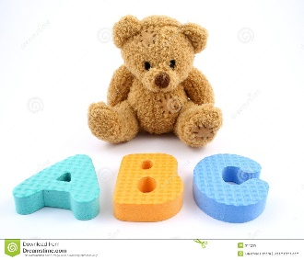

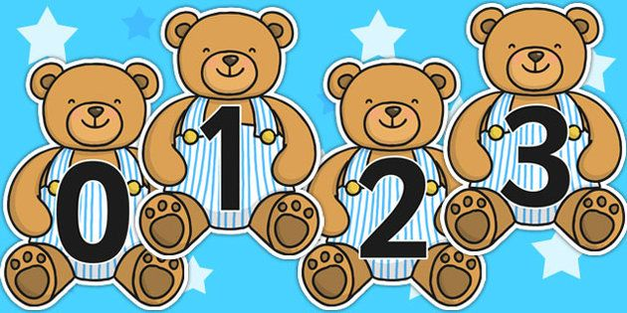

**Mathematics:** *Pupils will be supported to*

Combine objects like stacking blocks and cups.

Put objects inside others and take them out again.

Take part in finger rhymes with numbers.

React to changes of amount in a group of up to three items

Climb and squeeze themselves into different types of spaces.

Build with a range of construction resources – incorporating size and texture.

Complete inset puzzles.

Compare sizes, weights etc. using gesture and language - ‘bigger/little/smaller’, ‘high/low’, ‘tall’, ‘heavy’.

**Understanding the world:** *Pupils will be supported to*

Repeat actions that have an effect – using cause and effect toys, physical and vocal actions through play.

Explore materials with different properties – including temperature and texture variation.

Explore natural materials, indoors and outside – a particular focus on Autumn and seasons this term.

Use all their senses in hands-on exploration of natural materials.

Over this half term we aim to go on a local walk to see signs of Autumn.

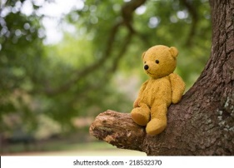

**Expressive arts and design** *Pupils will be supported to*

Show attention to sounds and music incorporating movement.

Anticipate phrases and actions in rhymes and songs, like ‘Peepo’.

Explore their voices and enjoy making sounds.

Join in with songs and rhymes, making some sounds.

Explore a range of sound makers and instruments and play them in different ways.

Notice patterns with strong contrasts and be attracted by patterns

Start to make marks intentionally.

Explore paint, using fingers and other parts of their bodies as well as brushes and other tools.

Enjoy and take part in action songs, such as ‘Twinkle, Twinkle Little Star’

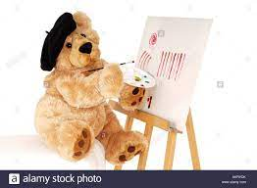

**Religious Education & Celebration Days:**

**(SMSCD/ RSE)**

Anti bullying - One kind word theme children’s friendships in class and in the playground will be scaffolded and supported through tolerance, sharing and turn taking

Through a focus of Where do I belong? and Myself and celebrations we will learn about celebration events through music, food and expressive arts incorporating:

Diwali

Bonfire night

Christmas

**Parents please share celebrations that are personal to the pupils.**

