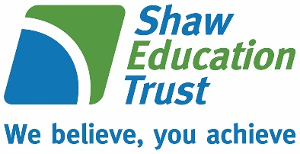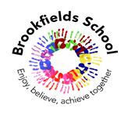

**Brookfields School**

**Moorfield Road, Widnes**

**Cheshire, WA8 3JA**

**Tel:     0151 424 4329**

**Fax:    0151 495 3460**

**Headteacher: Mrs Sara Ainsworth**

**Email:** [**sec.brookfields@halton.gov.uk**](mailto:sec.brookfields@halton.gov.uk)

**Website:** [**www.brookfieldsschool.com**](http://www.brookfieldsschool.com)

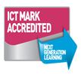





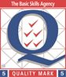

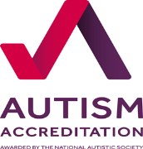

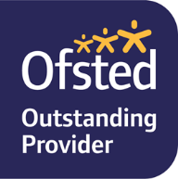

Dear Parent/Carers

Firstly I would like to welcome you to Brookfields School. This information has been put together to help you with some administrative processes we have in place.

**Payments to school**

Brookfields uses a cashless system for payments for school meals, snack, visits and uniform. This means that you will be able to make online payments via the School Gateway smartphone app or website. You will also be able to view school snack balances and top them up at any time.  We hope that you will find School Gateway to be a fast and easy way to pay for school items.

**What you need to do:**

***Download the app***: If you have a smartphone, please download School Gateway from your app store (Android and iPhone). The app shows the same information as the website.**OR**

***Visit the website***: [www.schoolgateway.com](http://www.schoolgateway.com) and click on ‘New User’. You’ll be asked for the email address and mobile number that school use to contact you on. You’ll receive a text message with a PIN number. Use this PIN to login to School Gateway.

**Communication with school**

We often send text messages to parents /carers to inform you of event information or reminders. Please ensure that you keep the school office informed of any changes to your mobile telephone number or email address.

**School Meals**

Every child has the option of having a school meal or bringing a packed lunch. The Government currently offer a free school meal under their Universal Free School meal scheme to all children in reception, Y1 and Y2. We understand that your child may have specific eating habits and you may prefer to send them in with a lunch provided by home but we would be more than happy to supply them with a school meal to help develop their tastes and try new foods.

Families may be able to claim Free School Meals from the Local Authority, although this will not make any difference to you paying for school meals currently, it does financially enhance our school budget to provide additional resources and services for your child. This is a means tested entitlement and we encourage families in receipt of benefits to make a claim.

**Snack**

Each morning and afternoon the children will have ‘snack time’. This too is an ideal opportunity for them to try new foods. Snack is provided by school, however we do have to charge 40p per day. The snack is a healthy option and varies each day from cereal, toast, fruit, biscuits, crackers etc. If you would prefer to provide a snack from home, again you are more than welcome to do so and you won’t be charged.

**School Uniform**

Brookfields uniform is currently supplied through Essential School Wear and we are currently in the process of introducing online ordering directly with them as an option for parents and carers to choose. In the meantime, orders should be placed via the school office by completing an order form. Usually payment will be made via the school gateway but this is only available once your child starts in September, so payment can be made by cash or cheque.

Please contact me if you have any questions regarding these procedures.

Yours sincerely

Lynsey Williams

Finance & Admin Assistant

