
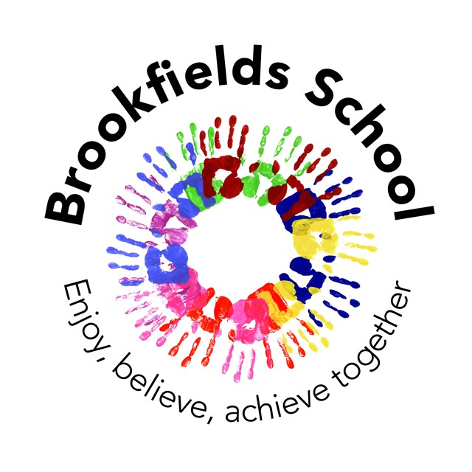
BROOKFIELDS SCHOOL HOME-SCHOOL CONTRACT

Brookfields School aims to meet pupils’ individual needs in a happy, supportive environment. As a school we will make every effort to:
- Give pupils equal access to a broad, balanced and relevant curriculum, regardless of race, gender or creed.
- Provide a safe, happy, caring and stimulating environment wherein each pupil is able to develop to their maximum potential.
- Promote the development of communication skills.
- Develop self-awareness, self-esteem and confidence in all pupils.
- Foster good working relationship between pupils, staff and parents.
- Make the learning process enjoyable and engaging.
- Encourage the development of appropriate British values, standards of behaviour and participation in society.
- Ensure that the transition between Primary and Secondary schooling is as smooth as possible.

Signed: S. Ainsworth (Headteacher) Date: September 2019

Partnership with parents is vitally important if we are to achieve our long term aims for the pupils.

I agree to work in partnership with Brookfields School to meet the educational needs of my child.

I have read the home-school contract 2019-20 and agree to follow its principles.

Pupil Name___________________________________________________

Signed ________________________________ Date __________________

Are there are other ways you would like to become more involved in your child’s life at school? E.g. volunteer work within school - swimming, rebound, outings etc.; fundraising (PTFA) and/or any other ideas you may have.

Please write down any suggestion in the box below.

NB: Any activities involving direct work with the pupils/students would be subject to a full DBS check.

Name ________________________________ Date __________________

Home-School Contract Rationale:

At Brookfields School we are very fortunate to have supportive and friendly parents and carers.
Our parents and carers recognise that educating children is a process that involves partnership between home and school and understand the importance of a good working relationship to equip children with the necessary skills for adulthood. For these reasons we welcome and encourage parents/carers to participate fully in the life of our school.

The purpose of this agreement is to provide a reminder to all parent and visitors to our school about expected conduct so that we can work together to ensure a safe and positive school environment for our children.

Respect and concern for others and their rights

This guidance supports implementation of the Home-School Agreement. We expect parents and carers to show respect and concern for others by:-

- supporting the respectful ethos of our school by setting a good example in their own speech and behaviour towards all members of the school community;
- working together with teachers for the benefit of children. This includes approaching the school to resolve any issues of concern and to discuss and clarify specific events in order to bring about a positive solution;
- reinforcing the school’s policy on Behaviour;
- respecting the learning environment appropriately (both in school and off site),

In order to support a peaceful and safe school environment, the school does not tolerate:-

- disruptive behaviour which interferes with the operation of school
- using loud and/or offensive language or displaying temper;
- threatening harm or the use of physical aggression towards another adult or child.
- damaging or destroying school property;
- abusive, threatening, malicious or inflammatory emails, phone or social network messages
- smoking and consumption of alcohol or other drugs or accessing the school site whilst intoxicated

The above behaviours on school premises will be reported to the appropriate authorities and Governors may prohibit an offending adult from entering the school grounds to safeguard our school community.

We trust that parents, carers and visitors will fully support this Code of Conduct.

Social Media Websites (Facebook etc)

Social media websites are being used increasingly to fuel campaigns and complaints against schools, Headteachers, school staff, and in some cases other parents/pupils. Brookfields School considers the use of social media websites being used in this way as unacceptable and not in the best interests of the children or the whole school community.
Any concerns you may have must be made through the appropriate channels by speaking to the Class Teacher, the Headteacher or the Chair of Academy Council, so they can be dealt with fairly, appropriately and effectively for all concerned.

In the event that any pupil or parent/carer of a child being educated at Brookfields School is found to be posting libellous or defamatory comments on Facebook or other social network sites, they will be reported to the appropriate 'report abuse' section of the network site. All social network sites have clear rules about the content which can be posted on the site and they provide robust mechanisms to report contact or activity which breaches this. The school will also expect that any parent/carer or pupil removes such comments immediately.

In serious cases the school will also consider its legal options to deal with any such misuse of social networking and other sites. Additionally, and perhaps more importantly, is the issue of cyber bullying and the use by any member of the school community to publicly humiliate another by inappropriate social network entry. We will take and deal with this as a serious incident of school bullying.

