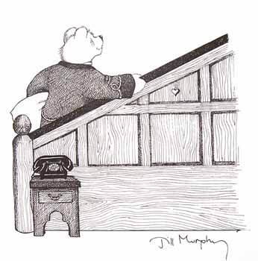 

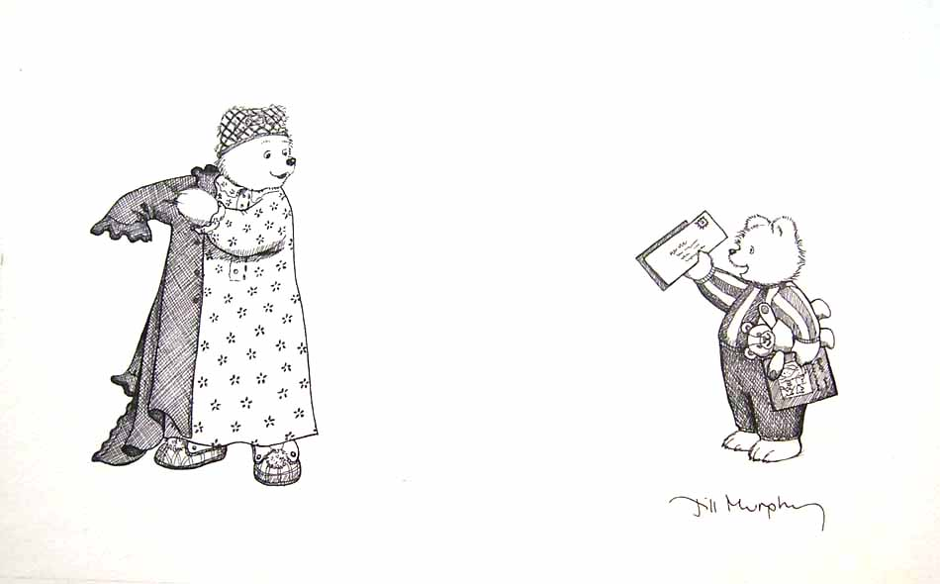 

 

 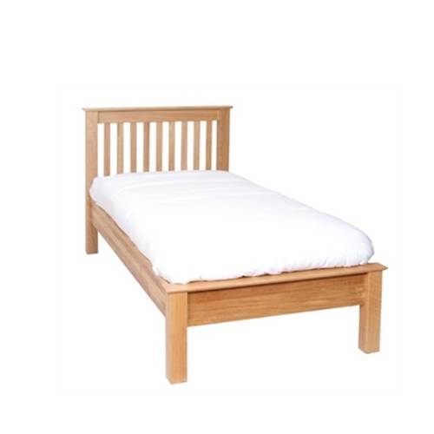

 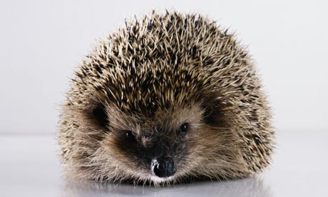

 

 [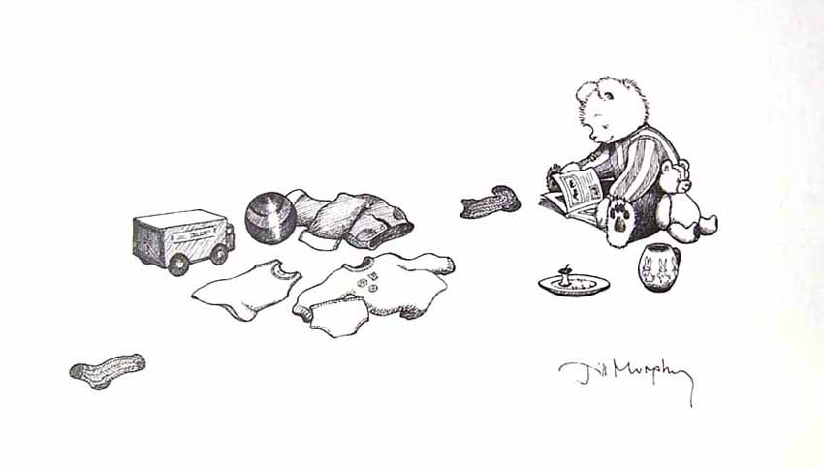](http://www.illustrationcupboard.com/uploads/illustrations/fb961b98-1d41-4aff-ab1b-7e8dcf0c050c.jpg)

 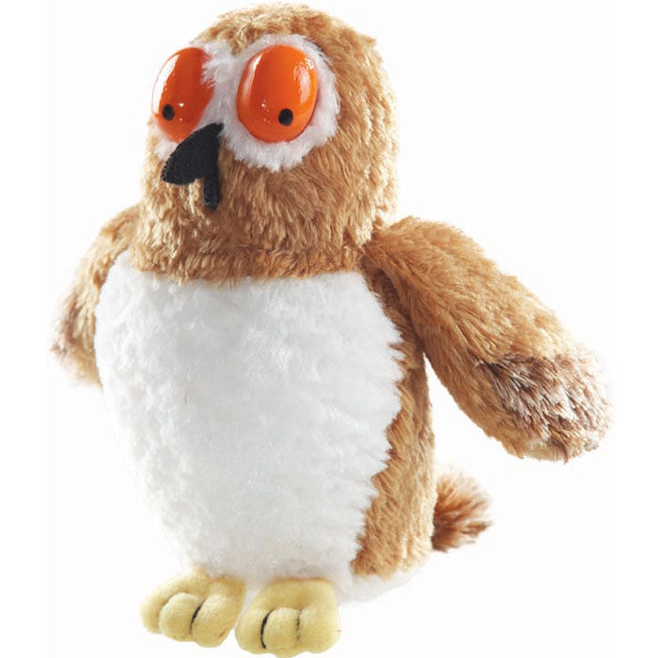

 [](http://www.illustrationcupboard.com/uploads/illustrations/fb961b98-1d41-4aff-ab1b-7e8dcf0c050c.jpg)

[](http://www.illustrationcupboard.com/uploads/illustrations/fb961b98-1d41-4aff-ab1b-7e8dcf0c050c.jpg) [](http://www.illustrationcupboard.com/uploads/illustrations/fb961b98-1d41-4aff-ab1b-7e8dcf0c050c.jpg)

 

[](http://www.illustrationcupboard.com/uploads/illustrations/fb961b98-1d41-4aff-ab1b-7e8dcf0c050c.jpg) 

[](http://www.illustrationcupboard.com/uploads/illustrations/fb961b98-1d41-4aff-ab1b-7e8dcf0c050c.jpg)  

 

