Go for a walk and take pictures of objects the different colours of the rainbow.  For example, red bike, yellow ball | 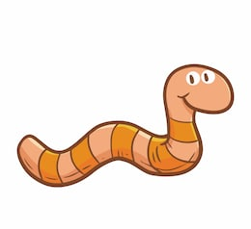  In your garden find a spider, a worm and a bird | Go for a run, scooter or bike ride | 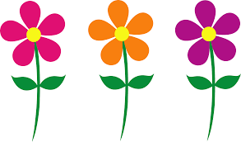  Find three different coloured flowers
Have a sports day!  Wheelbarrow races  Egg and spoon race  Tug of war  Sack race | How many rainbows can you find on your walk? | How many different animals can you find when out on your walk?  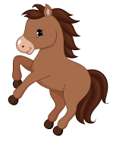 | Try an outside workout  Star jumps  Hopping  Skipping  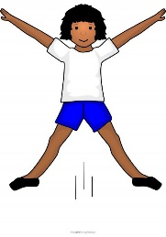  Can you try a plank!
Summer Bingo card!
It’s summertime! Time to get outside and keep active. See if you can complete these challenges on your daily walk or in your garden. Give the boxes a tick or take photographs and send them to stclark@brookfields.halton.sch.uk we would love to see your pictures! Have fun!
Bingo card 2!
Here is your next challenge! Enjoy and have fun!
Find a pile of leaves to crunch! | can you spot a tree and a flower on your walk?  What colour is the flower? | Get outside for a run | Can you do a hop, skip and a jump?
It’s raining outside, put on your wellies and go for a splash!  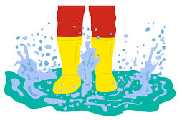 | Can you hear a bird chirping? | Go feed the ducks!  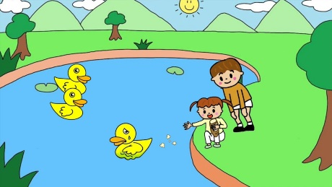 | How many different colours can you find in your garden/ on your walk?  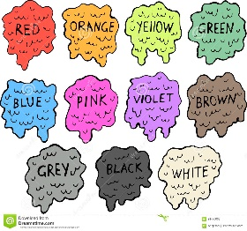

Colour chart to support bingo card
Mark which colours you can find.

The colour | Can you see it?  Give a tick | What was the object?
Red
Yellow
Pink
Green
Orange
Purple
Blue

