|  |
| --- |
| **Class: Hawks Term: Autumn Term 1 - 2021 (September - October) Explorers & Adventurers** |

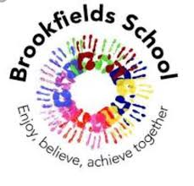

Communication & Language / English – Language & Communication

This term we will be using our English skills to look in depth at the different characters in different story books. Colourful semantics will be a visual use of support when speaking and writing imaginative and exploring the stories further. We will extend our knowledge by reading traditional tales, poetry, factual texts with lots of adventure and mystery! Using our detective skills, we can search the texts and re-write our own versions along with using role-play to consider the different points of view of the different characters.

Read, Write Inc is the scheme of work we will follow to learn our letter sounds and names, word build and support us in learning those ‘tricky words’.

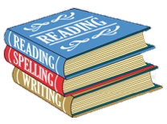

Thinking & Problem Solving / Maths – Thinking, Problem Solving & Finance

Monday – Experience number

Tuesday – 2D & 3D Shapes

Wednesday – Capacity (big / small 🡪 full / empty)

Thursday - shop, money, problem solving, water play, time (learning through play)

Monday – Number

Tuesday – Size & Shape

Wednesday – Size & Capacity

Thursday – Time

We will use our PE slot to practice problem solving games and support our teamwork & building strategies. These skills will also be embedded throughout our curriculum and learning.

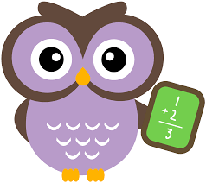

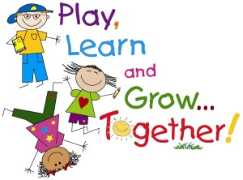

Thematic Learning:

My World & My Community / Understanding My World & My Community

Collective Worship is timetabled at the start of each school day. We have an allocated section on our bookshelf where children can freely choose. This term the books within the worship section will explore some of the key elements underpinning our Brookfield’s Curriculum; emotions, friendships, belonging and sharing.



Myself & My Body / Personal Social & Emotional Development

We will start the school year by learning about ourselves and getting to know others around us. We will be learning about our likes and dislikes and who is important to us. We will be working hard to form friendships and how important it is to be a good friend and the qualities needed. We will be discussing the different emotions the human body can experience and what these can each look like whilst working towards finding calming and self-regulation strategies to support us.

‘What is a home’ is our first topic which will allow us to explore the characteristics of our own and others homes. For example the shapes in our homes, the colour of our door / window.

Our Adventurers will be expanding their learning by delving into different topical issues looking at both the role and impact of the media. One issue we will deeply focus on will be recycling: What is recycling? What materials are recyclable? This will be put into practice when we become active citizens ourselves looking at how we as both a class and a school and local area can make a difference.

Our Explorers will be focusing on the daily routines we as humans make to keep healthy such as brushing our teeth, getting washed and dressed. Their learning will also be expanded by looking at those who help us with lots of opportunities for learning through play.

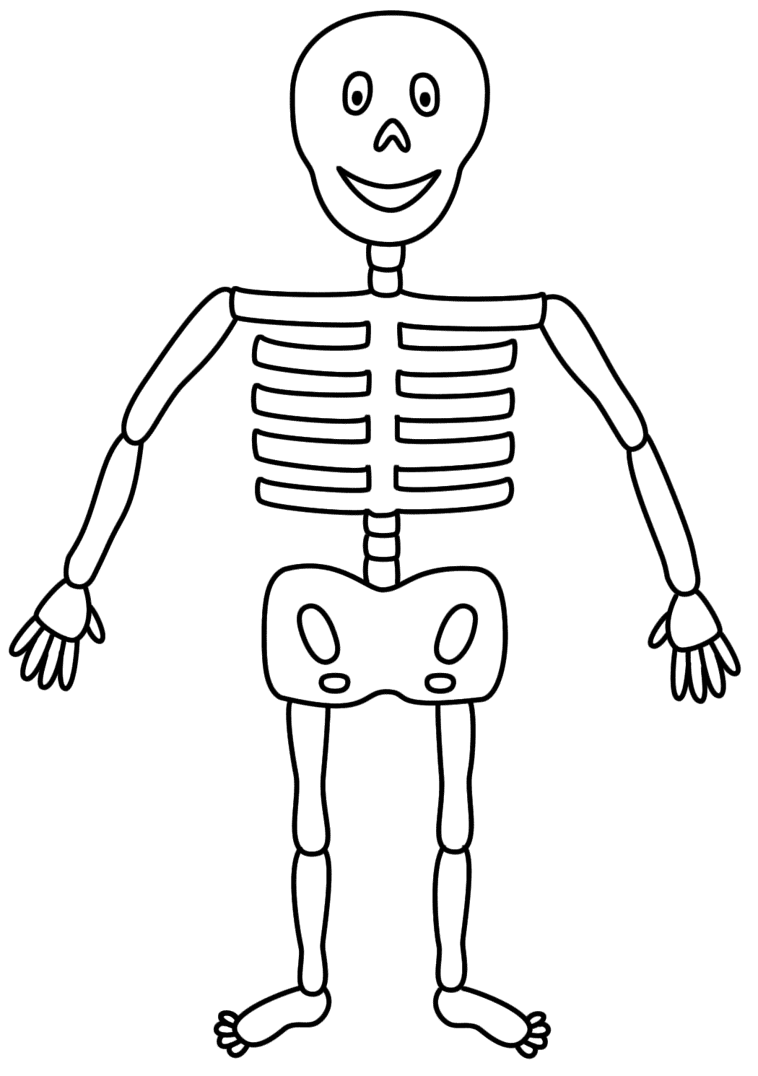

I am excited to start this year on a happy and positive ambiance after what has been a tricky and uncertain time for us all especially our children & their families. This term is dedicated to getting to know each and every child on an individual basis and support them in feeling safe and building secure relationships. I am eager to embark on this learning journey alongside the children and watch them flourish as the term progresses.

Learning through play:

This term under ‘What is a home’ with will be using experimental play to explore different pets, expanding our knowledge and getting to know one another by discussing what pets live in our homes. We will explore different objects of reference of the human body such as skeleton bones, and heart shaped sponges again through experimental play. Opportunities to learn through play will occur in other subjects: choose time, extension activities, PE sessions, learning beyond the classroom (Soft play, outside play, tyre park, light room).

Life Skills – Understanding the World I Live In

This term we will be looking at where we belong as individuals. This will involve our school, who lives with us and our family and friends. This will help us to understand about those who are less fortunate and become appreciative, grateful individuals (key characteristic qualities ☺!).

Our science topic (Living things and their habitats) will include talking about pet’s that live in our home before going on to use our senses, explorative learning and play to discover the habitats of different animals, in different climates. Weather conditions and environmental changes are going to underpin our learning through-out this term as we will become miniature meteorologists and look at these changes and how animals and humans adapt to this.

animal adaptations,.

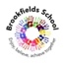

My Creativity / Creative Development

This term we will to look at the work of famous Artists as inspiration to become young Artists ourselves: using different malleable materials, painting and drawing to create portraits of ourselves and our friends.

Musical instruments will be explored and replicated using our own recycled products – we will explore echoes and sounds in our environment whist learning beyond the classroom. Different rhythms, pitches and patterns will be discovered and investigated whilst listening to different genres and mood contrasts of music.

Construction as a skill will be a big focus of our term as we construct small world areas for our animals in our cross-curricular learning, create Lego home for our animal habitats.

