|  |
| --- |
| Class: Hawks Term: Summer Term- 2024 (April – July) Explorers & Adventurers |



Communication & Language / English – Language & Communication

The Explorers this term will use songs and story rhymes to engage themselves. They will share the weekly books with adults, developing their understanding and working on their early reading skills, including attention building activities and Attention Autism.

The Adventurers will continue their work and continue to develop around the reading and writing skills. They will follow the RWI scheme to develop their phonic knowledge. We will be exploring stories during ‘Talk 4 Writing’ and will learn to write creatively using descriptive language. Our first story this term is ‘Grandad’s Island’ by Benji Davies.

Read, Write Inc is the scheme of work we will follow to learn our letter sounds and names, word build and support us in learning those ‘tricky words’.

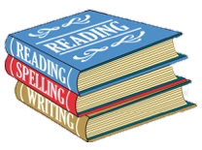

Thinking & Problem Solving / Maths – Thinking, Problem Solving & Finance

During Summer Term, our Adventurers will continue to widen their Mathematical skills to learn about Fractions, Time, Statistics, Position and Direction.

Our Explorers will begin to explore Number including early number and place value. They will explore thinking and problem solving in real life such as exploring fractions of food to find halves, sequencing times of day and following directions on a treasure map!

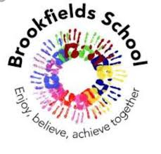

Thematic Learning: Let’s Pack!

My World & My Community / Understanding My World & My Community

This term our topic ‘Let’s Pack’ allows us to explore our wider world, including countries of the world, weather, animals and finding out questions such as ‘What is the world’s tallest mountain/longest river?’.

We will compare hot and cold regions of the world and decide what clothes we would pack on holiday to different places

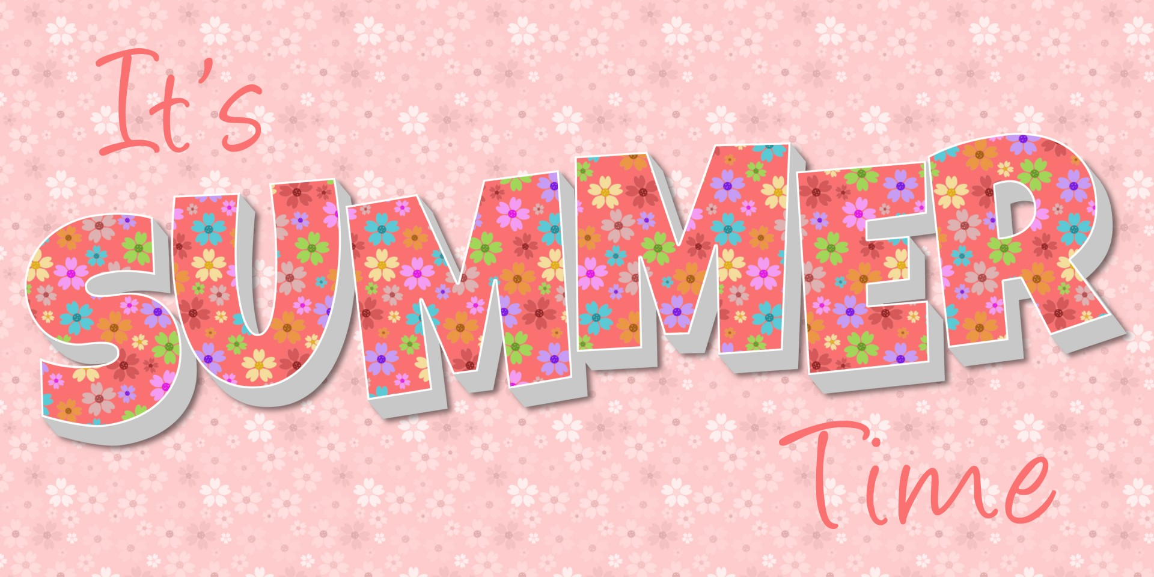

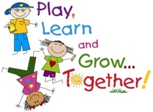

Learning through play/Myself and My Body:

This term as part of our ‘Let’s Pack’ topic, we will be using experimental play and role play to explore all about holidays and adventures. We will explore lots of objects of reference such as different clothing we wear, food we eat, transport, etc all as part of our continuous provision. Opportunities to learn through play will occur in other subjects: choose time, extension activities, PE sessions, learning beyond the classroom and Educational Visits.

We will use our PE slot to practice problem solving games and support our teamwork & building strategies. These skills will also be embedded throughout our curriculum and learning. This term we will participate in Cheshire Cricket,, Karate and Swimming as part of our PE curriculum.

Myself & My Body / Personal Social & Emotional Development

This term we will be continuing to look at emotions. This will involve a continued theme of emotional awareness and regulation as we change and develop.

In particular, we will be looking at mental wellbeing and happiness. What things make us happy? How can we benefit from exercise? What are our hobbies and interests? How can we share hobbies to develop our relationships?

We will continue to explore regulation strategies and how these can develop our emotional and physical wellbeing..

My Creativity / Creative Development

This term, we will explore art and design through our topic ‘Let’s Pack’. We will design, make and evaluate our own transport vehicles in Design Technology, looking at how different vehicles are used to transport across the world.

Musical instruments will be explored - we will explore high quality live and recorded music, linked to the Seaside, Rainforest and Space. We will also engage with specialist music sessions with Eleanor, to unleash our musical talents!

What a year we have had! I can’t believe we are on the last term with the children and our learning journey together. The children have continued to impress me over and over again throughout the year. They have all built lovely relationships with the peers and staff as we have with them. Here is to the last term of making memories, having fun and excelling in progress!