|  |
| --- |
| **Class: Hawks Term: Autumn Term 1 - 2022 (September - October) Explorers & Adventurers** |

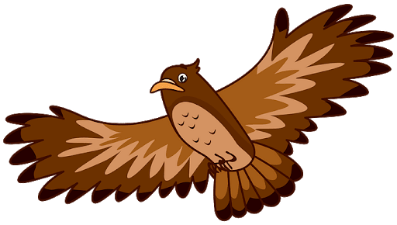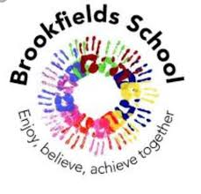

Communication & Language / English – Language & Communication

This term our Explorers will be using their communication skills to make choices, express opinions and request our needs and wants. We will build our attention and listening skills through Attention Autism and Intensive Interaction, as well as develop our early writing skills through fine motor and sensory activities. We will explore a variety of sensory stories to develop our language and sequencing skills.

Our Adventurers will look in depth at a range of stories and texts. Colourful semantics and Talk for Writing will be a visual use of support when speaking and writing to develop the use of sentence structure. Read, Write Inc is the scheme of work we will follow to learn our letter sounds and names, word build and support us in learning those ‘tricky words’.



Thinking & Problem Solving / Maths – Thinking, Problem Solving & Finance

In Thinking and Problem Solving, we will experience number and counting whilst using problem solving skills. We will explore shapes through hands on sensory activities and exploring shapes within our environment. We will increase our thinking and independence skills whilst learning about measurement, such as big, small, full and empty.

In Maths this term, Adventurers will cover number, size, shape, capacity and time.

We will also develop our teamwork and problem solving skills through PE and cross curricular activities.

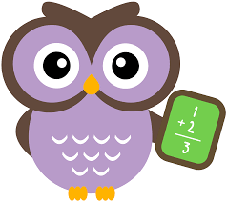

Myself & My Body / Personal Social & Emotional Development

‘The Magic of Being Human’ is our first topic which will allow us to explore the human body and the magical fascinating’s of being human. We will get the chance to be young scientists and investigate skeletons. We will be discussing the different emotions the human body can experience and what these can each look like whilst working towards finding calming and self-regulation strategies to support us. We will be working hard to form friendships and how important it is to be a good friend and the qualities needed.

Our Adventurers will be expanding their learning by delving into different topical issues looking at both the role and impact of the media. One issue we will deeply focus on will be recycling: What is recycling? What materials are recyclable? This will be put into practice when we become active citizens ourselves looking at how we as both a class and a school and local area can make a difference.

Our Explorers will be focusing on the daily routines we as humans make to keep healthy such as brushing our teeth, getting washed and dressed. They will be exploring their senses as part of being a human and using our senses to explore a range of materials and equipment. Their learning will also be expanded by looking at those who help us with lots of opportunities for learning through play.

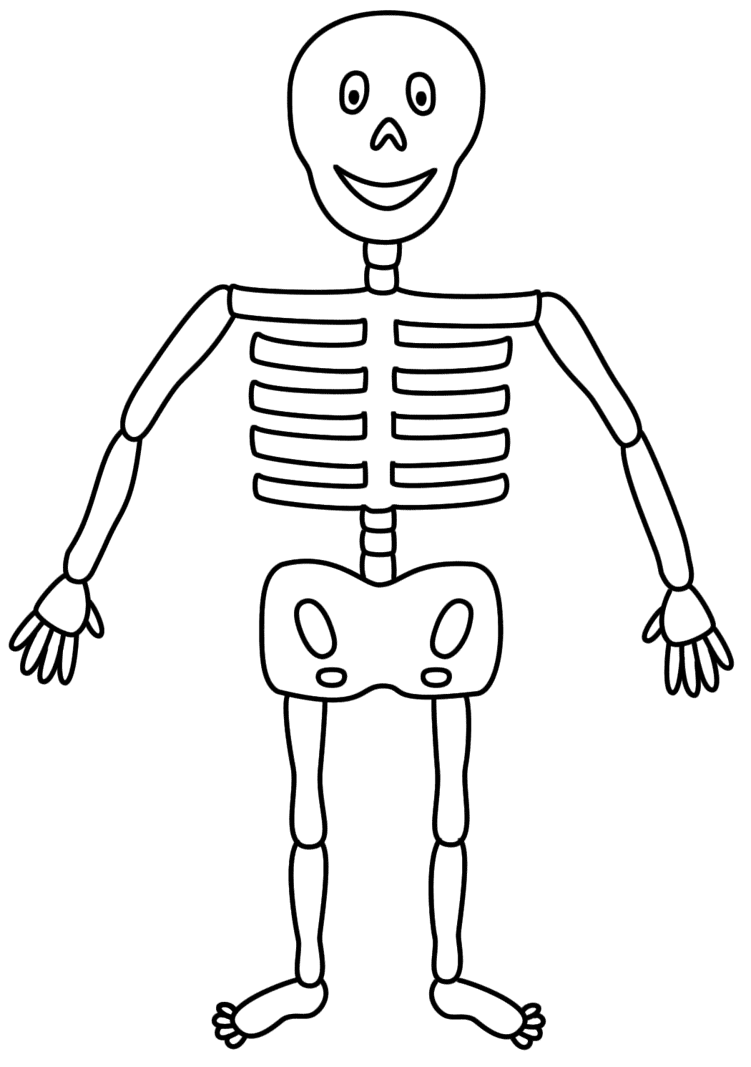

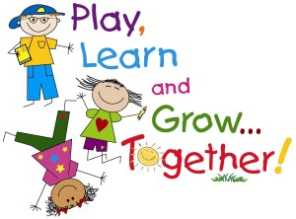

Hawks class are excited for a positive year full of fun and learning. This term is especially important for building secure relationships, to support our children in feeling safe and happy as they continue to flourish on their learning journey. We also wish to support our families and carers, the class team are always happy to help if you would like to share any celebrations, questions or worries.

Life Skills – Understanding the World I Live In

This term we will be looking at where we belong as individuals. This will involve our school, who lives with us and our family and friends. This will help us to understand about those who are less fortunate and become appreciative, grateful individuals (key characteristic qualities ☺!).

Our science topic (Animals including humans & Living things and their habitats) will include talking about pet’s that live in our home before going on to use our senses, explorative learning and play to discover the habitats of different animals, in different climates. Weather conditions and environmental changes are going to underpin our learning through-out this term as we will become miniature meteorologists and look at these changes and how animals and humans adapt to this.

animal adaptations,.

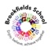

Learning through play:

This term under ‘Animals including humans’ with will be using experimental play to explore different pets, expanding our knowledge and getting to know one another by discussing what pets live in our homes. Opportunities to learn through play will occur in other subjects: choose time, extension activities, PE sessions, learning beyond the classroom (Soft play, outside play, tyre park, lightroom).

Thematic Learning:

My World & My Community / Understanding My World & My Community

Collective Worship is timetabled at the start of each school day. We have an allocated section on our bookshelf where children can freely choose. This term the books within the worship section will explore some of the key elements underpinning our Brookfield’s Curriculum; emotions, friendships, belonging and sharing.



My Creativity / Creative Development

This term we will to look at the work of famous Artists as inspiration to become young Artists ourselves: using different malleable materials, painting and drawing to create portraits of ourselves and our friends & the human body. Construction as a skill will be a big focus of our term as we construct small world areas for our animals in our cross-curricular learning, create Lego people with their body parts and create instruments.

Musical instruments will be explored and replicated using our own recycled products – we will explore echoes and sounds in our environment whist learning beyond the classroom. Different rhythms, pitches and patterns will be discovered and investigated whilst listening to different genres and mood contrasts of music.

