Peace at Last
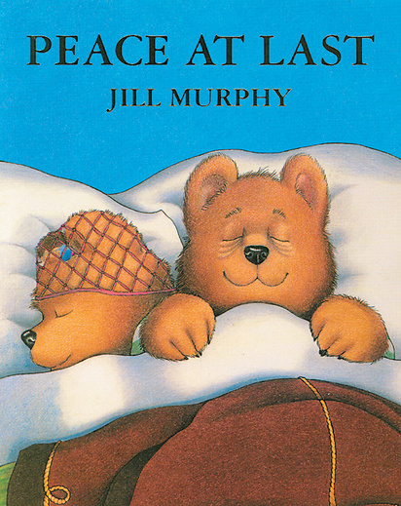
Reading Comprehension.

Tick the right box:
What is the title of the book? | A Long way home.  Peace at last.
Who is the author of the book? | Brown Davies.  Jill Murphy  Sophie
How many Bears were in the story? | Three  Seven
Who was snoring in the story? | Mr Bear  Mrs Bear  Baby Bear
What was Baby Bear pretending to be? | A fire engine  An aeroplane
Where did Mr Bear hear the clock ticking? | The bedroom  The kitchen  The living room
How do you think Mr Bear felt in the morning? | Tired & exhausted  Refreshed
What woke Mr Bear up? | The television  The alarm clock

Helpful hints:
&
Means and
Self Assessment

ANSWERS:
- Peace at last
- Jill Murphy
- Three
- Mrs Bear
- An aeroplane
- The living room
- Tired and exhausted
- The alarm clock

