A handy guide for travelling to school 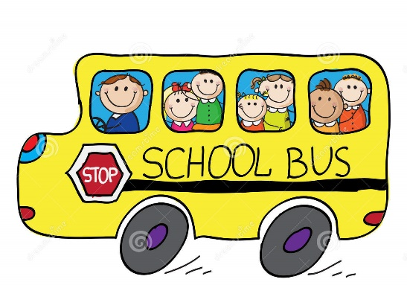
Transport may be provided to and from Special Schools depending on the distance you live from school. Usually the transport will be discussed whilst your child’s special educational needs are being assessed. If transport is deemed necessary, then it will be included in their Education Health Care Plan or statement of special educational needs that may be produced at the outcome of the assessment. However, some parents/carers may initially want to transport their child themselves but as they settle at school or get older then they may decide to use the transport that is available to their child free of charge. This can again be discussed at Annual Review or at any point using the routes below. In order to set up transport parents/carers should liaise directly with LA transport team as school does not arrange transport but will support your application.
- For pupils who do not currently travel on school transport:
For information about setting up transport contact Transport Coordination on 0151 511 7444; TransportCo-ordination@halton.gov.uk or Susan Paine at Halton SEN Team on 0151 511 7191
You will need to fill in a transport request form that contains a wide range of information about your child as well as your address etc. This will be provided by the SEN team.
For support and advice please do not hesitate to contact school as we can provide further information either to you or to the local authority to support your request. School phone number is 0151 424 4329
- For pupils who already have transport in place:
If you are experiencing any difficulties with the transport that is being provided for any reason or the transport has not turned up etc, please contact the transport team directly on 0151 511 7444
- For any other transport related enquiries:
Please contact Halton Direct Link for more information, phone 0303 333 4300 or visit one-stop shop (Halton Lea, Runcorn or Widnes).
Transport Tips:
- It is a good idea to ensure that you have the mobile number of the driver / escort from your child’s vehicle then you can contact them to notify them if your child is poorly and doesn’t need collecting on a certain day. Please ensure that you do contact them if they are not required for any reason or if someone else is collecting them / taking them to school for any reason.
- If the transport has not turned up or is very late in a morning, then please contact the driver / escort or the transport team to find out where they are rather than school as we do not hold contact details for the buses and taxis. If they have not turned up and your child will be late, please do let the school office know.
- If your child requires medication and this is being sent into school, please make sure that this is given to the driver / escort and is not in the child’s bag where it is accessible to your child or others.
- Please do not pass messages via transport personnel to school. Please use the home-school book or telephone to speak to the school office or your child’s class teacher. This is the same for school; we will always converse with you directly via the home-school book or telephone and will not pass information via transport staff.

