Peace at Last Word search.
P | W | B | E | A | R | W | S | U | N
E | E | S | Q | O | P | E | R | T | Y
A | T | D | X | H | O | U | S | E | H
C | C | F | Z | I | X | F | G | H | B
E | V | K | I | T | C | H | E | N | I
S | S | N | O | R | E | R | F | G | R
L | O | G | B | K | A | R | B | I | D
A | W | B | H | J | S | O | A | O | S
S | L | E | E | P | E | O | C | A | R
T | T | D | Y | U | I | M | L | K | J

Words to find:
PEACE AT KITCHEN SNORE
LAST SLEEP ROOM CAR
BEAR BED
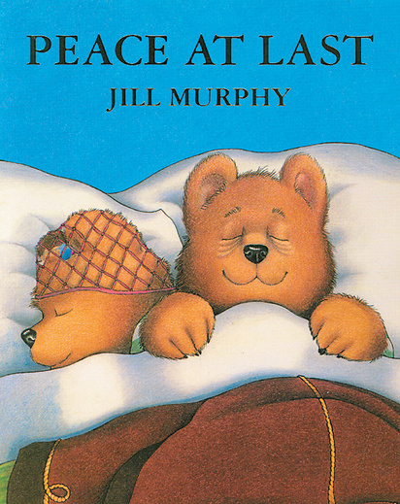
OWL SUN
HOUSE BIRDS

Self Assessment
Self Assessment

