Arrival and Departure Guidance (children) Supervised by Sara and Emma.
Way in to school for staff and pupils. | 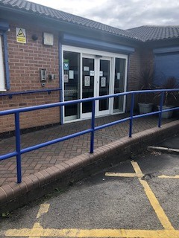  We shall operate a 1 way system. Children will be brought in through the main doors and then around the internal 1 way system.
Way out when going to collect children in the morning / take out to buses.  No transport personnel or parents are allowed in school  All children to remain in vehicles until collected by staff. | 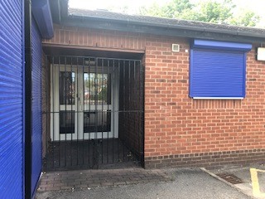  Staff going out to collect children will go out into the carpark via the side exit. Children will leave via this exit and staff will return into school through main doors at the end of the day.
Taxis / Buses | 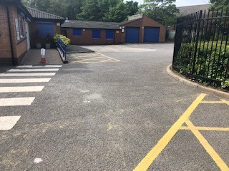  Taxis and buses have been split into 3 groups with 3 separate arrival times in the morning and afternoon.  Taxis and buses will park in the main part of the car park only.
Parents / carers  No transport personnel or parents are allowed in school | 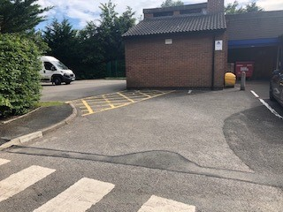  Parents will park in the church carpark and enter school through the pedestrian gate and then will wait in the side car park area for their child to be collected / dropped off.

