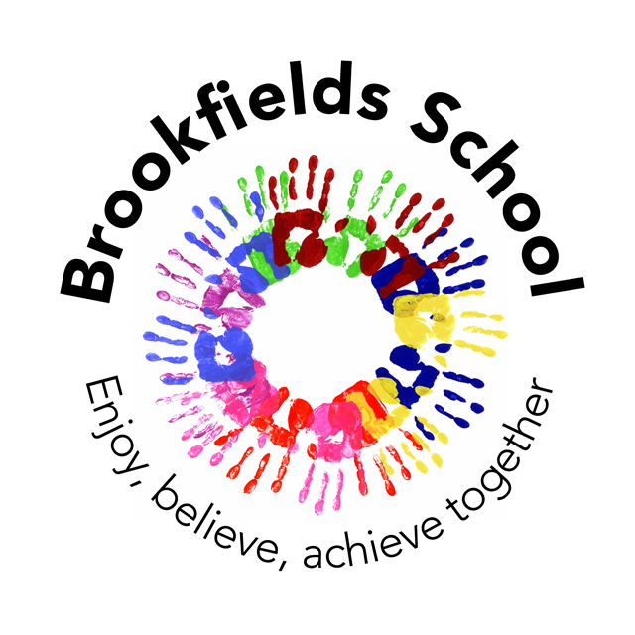Brookfields Statement on British Values.
Brookfields School is committed to serving its community and surrounding areas. It recognizes the multi-cultural, multi faith and ever-changing nature of the United Kingdom, and therefore those it serves. It also understands the vital role it has in ensuring that groups or individuals within the school are not subjected to intimidation or radicalization by those wishing to unduly, or illegally, influence them.
The school, as a ‘Community School’, accepts admissions from all those entitled to an education under British law, including pupils of all faiths or none. It follows the policies outlined by its governing body regarding equal opportunities, which guarantee that there will be no discrimination against any individual or group, regardless of faith, ethnicity, gender, sexuality, political or financial status, or similar. It seeks to serve all.
The Government emphasizes that schools are required to ensure that key ‘British Values’ are taught in all UK schools. The government set out its definition of British values as:-
- Democracy
- The rule of law
- Individual liberty
- Mutual respect
- Tolerance of those of different faiths and beliefs
The school does, through a wide range of activities, aim to meet these standards and uses strategies within the National Curriculum and beyond to secure such outcomes for children. The list below outlines samples of when and where such British Values are shared. The list is not exhaustive, and represents only some of what we do.
Curriculum: Developing the skills required to communicate, make/express choices and find out information. These include writing and reading skills, number skills; including developing an understanding of money, independent and collaborative work, and activities designed to gain a an understanding of the place and society in which they live at a level appropriate to their understanding. The curriculum covers historical and geographical learning about the United Kingdom, as well as international comparisons e.g. through our link schools in South Africa.
Whole school daily acts of collective worship/assembly: The sharing of stories, images, events, music and expectations promote the values and ethos of the school that have their roots in our school rules. These activities take place in a wide range of ways in order to engage the children and be presented at an appropriate level for understanding. As a ‘community school’, ‘collective worship’ is nondenominational and recognizes that those attending may have a wide range of faiths, or none. It is however, in line with regulation and is “wholly or mainly of a broadly Christian character”.
Religious Education: This involves gaining a greater understanding of religious diversity and practices, which covers key religions represented in the UK. Planning for the subject is directed by the ‘Standing Advisory Council on Religious Education (SACRE) – Agreed Syllabus for Religious Education’ which is used by all Primary Schools in Halton.
Physical Education: The following concepts are developed through our PE curriculum and also through the pupils engagement with external coaches; following and developing rules, inclusion, celebrating and rewarding success, participation in activities that promote working and playing together and teamwork.
Learning Outside the Classroom: Weekly educational visits allow the pupils the opportunity to have a wider set of learning experiences beyond the school building itself. These visits support all aspects of the children’s learning and reinforce and expand upon the taught curriculum. Visits include activities that support Maths and Communication e.g. visiting shops and café’s; activities that support History and Geography with visits to local landmarks and places of interest; trips to provide real life experiences of different cultures and religions, whilst underpinning all of this is the opportunity to develop independence and self- confidence.
School Council: This involves members of KS2 and includes the pupils taking part in democratic processes (voting), sharing ideas and working together towards an outcome, planning for events, teamwork and the development of communication skills.
For more information about how the school seeks to represent key British Values, contact the school office and a member of the School Leadership Team will be happy to provide further information. Should you feel that the school is not meeting this requirement, you should contact the school office and request to express your concerns with the Headteacher. Likewise, if you feel that anyone working at the school is, intentionally or otherwise undermining these values, you should report this to the Headteacher.

Completed February 2015.

