

**Literacy**

Enjoys songs and sharing books with an adult.

Pay attention to words and pictures.

Pre-phonics policy

Intensive interaction

Explore and learn through objects of reference.

Enjoy exploring a book through simple talk 4 writing.

**Communication & Language:**

Copy what adults do, take turns in conversations, and intensive interactions, copying adult speech and lip movements.

Listen and respond to simple instructions and visual prompts.

Reach and point to what it is you want.

Understand simple words in simple contexts.

Respond to blank levels and focused activities, play based learning and experiences.

**Class: Foxes Term: Summer Term 2024 EYFS / Y1**

**Mathematics: Number**

Combine objects.

Take part in finger rhymes.

Change of amount – reactions

Climbs, squeeze and navigate through different spaces.

Build with a range of construction – incorporating size and texture.

Compare sizes, and weights and capacity through gestures and language such as ‘Bigger/Smaller / High/Low’ ‘Full/Empty’.

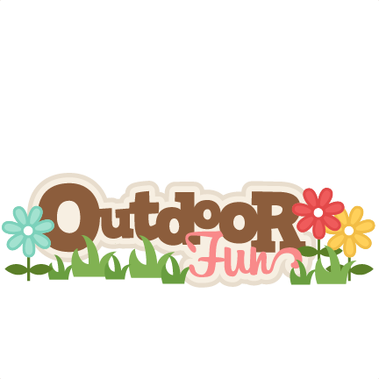

**Physical Development**

Enjoy throwing, catching, and kicking activities.

Skip, hop, and stand on one leg.

Structured simple games

Sports day

Develop balance and manipulation along with control.

Clap, stamp, and move your body to music.

Use large-scale muscle movements to wave flags and objects that fly to support topical learning.

Develop independence with undressing and dressing, taking care and responsibility for our belongings.

**Personal, social, and emotional development**

Use a range of communication to express preferences and choices.

Engage with other through gestures, gaze, talk and signs.

Focus on how we play – development of play.

Sharing space and resources with our peers

Develop turn taking and adult supporting us to share.

Feeling confident in out local area / mini-bus trips and so forth

Take care of our bodies and develop independence through hair brushing, teeth cleaning and handwashing.

**Expressive Arts and Design.**

Enjoy songs and rhymes to develop our levels of attention by joining in and copying sounds – incorporating sound makers and instruments and our voice as sound makers.

Anticipate phrases and actions in rhymes and songs / taking part.

Make marks with increasing intent and purpose outdoors and indoors.

Explore paint and other natural resources for multipurpose benefits using tools, brushes, mop, and our bodies.

Express ideas and feelings through mark making and giving meaning to our marks.

**Understanding the World.**

Repeat actions and understanding they have an effect through use of cause-and-effect toys.

Explore different materials such as plants, soil, sand and other messy resources for experiential learning and play.

Explore natural materials, indoors and outdoors, with different properties and capacities with a particular focus on the weather and season of this term.

Engage with sense as we continue through explorative learning and trips to garden centres, the beach and other woodland areas. 