Here are some of the most common outreach scenarios and some ideas and strategies to try. Remember, there are no magic wands any intervention takes time and patience to implement and take effect.
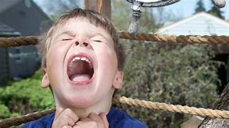
Child A has a meltdown whenever outside play is over. He runs away forcing staff to chase after him/her. By the time we eventually get him inside, he won’t engage in learning he throws equipment and is impossible to deal with.

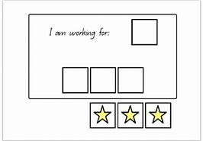
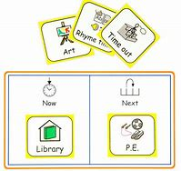
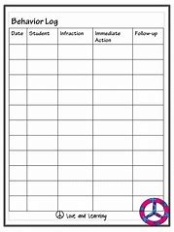
Child A might particularly enjoy outdoor play, have difficulty with transitioning in and out of doors (or even problems with transition in general) and/or may not like being in the classroom as much. Understanding the reason for the behaviour always helps. A behaviour log or diary can help to work out the cause of the behaviour if the child is not able to tell you. Using visual cues to aid transition are often helpful so a timer or finished sign or symbol could help. Introducing a small reward for the desired behaviour might also help. Staff need to stay calm, patient and wait rather than giving chase around the playground as the child has then achieved both avoiding going in and gaining a big reaction. All children need to be calm to be ready to learn so the behaviour on re-entering the classroom is not surprising. Making the transition calm and smooth from playground to classroom will make a big difference. However, a visual timetable and maybe a now /next board or working for board will provide structure to this.

Scenario 2
Child B is generally happy to complete individual work and usually works hard. However, when the class are doing group work she is like a different child. If she can be persuaded to join a group she will not interact in anyway with the group not even to listen to their ideas, she just sits and does the work set as an individual task. If challenged she will walk out of the room and it can take a long time to coax her back in.
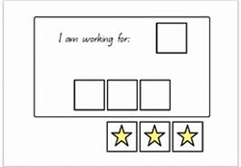
Children with ASD can find social interaction challenging for numerous reasons and it is important to be understanding. Control and structure are important for many children on the spectrum and group work can mean relinquishing control of their work to others. It could be overwhelming having lots of other children so close with sights, sounds and smells. Child B sounds quite academically able and so it might be possible for a trusted adult to talk to her (using visuals or a comic strip conversation technique to support) when she is calm and happy about group work and why it is important and to then make an agreed plan to help her take part; e.g. The first taste of group work might be with one other child who she feels comfortable with for an agreed period of time, building up at an agreed pace to more students for more time. Always give warning of group work using visuals and share the task in advance, choose groups carefully and ensure students chosen are empathetic. It might be good to add a ‘reward’ or motivator to help Child B to achieve the goal supported by a Working for Board.
If the issues are sensory – too noisy for example then head phones might help, but the gradual introduction of selected group members suggested above might also help.

Scenario 3
Child C presents a challenge at snack time and lunchtime. She will not sit at the snack table and can scream if made to. Lunchtime is another battle as she runs off whenever staff try to take her to the school dining room and makes gagging noises which upset the other students. She brings a packed lunch as she will only eat certain things. Behaviour before and after lunch is starting to suffer.
Children with ASD often have limited palattes and will have a limited range of foods they will eat or these are often what people refer to as bland foods. This could be because of smell, taste, touch or a reluctance to try new things. Child C might be distressed by the smells, sounds or sights of the dining room which could be causing sensory overload. Consider; Is there another safe space she can eat her packed lunch? I would guess she isn’t the only child who does not enjoy going into the dining room it could be part of the whole school strategy to offer an alternative for pupils who need a quieter less busy space to eat- (her own classroom or an area that can be supervised and the child is comfortable in). Social stories and /or visuals could be used to support.
https://www.autism.org.uk/about/strategies/social-stories-comic-strips.aspx
https://carolgraysocialstories.com/social-stories/what-is-it/
