General Advice and tips for an ASD friendly classroom
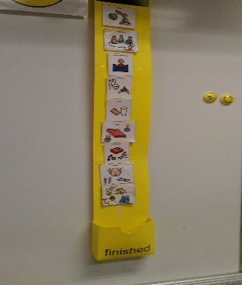
- Have a clear, shared routine
Having a clear timetable that is shared with the children will make everyone feel secure and happier. We all like to know what is going to happen during the day and this is especially important for children with ASD as structure helps reduce anxiety.

- Use visuals to support learning and behaviour
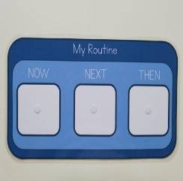
Support learning and behaviour with visuals for example timers can signal the end of an activity.
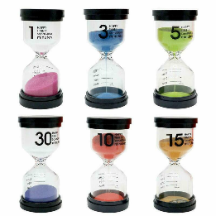
There are a few reasons for this – children with ASD sometimes struggle with verbal communication and can struggle to understand and / or process information. Visuals like pecs symbols or Makaton signs can aid understanding and lessen anxiety resulting in more positive behaviours. Transitions can also be difficult for children with ASD visuals can help with this.

- Keep the environment clutter and distraction free
Clutter and busy displays or bright colours and patterns can cause visual disturbance in some children with ASD (hypersensitive) as they notice tiny detail, so lots of clutter, colour etc. can cause overload as they try to process the visual information. Some children with ASD can be under-stimulated (hyposensitive) so visually stimulating things can be used to stimulate a child who needs this.

- Manage transitions with patience and understanding
We all work harder at the things we enjoy and a child with ASD can become engrossed in activities they enjoy and changing or ending the activity can cause problems. Adding some scaffolds to help them understand that a task is about to end /has ended will help. Timers can help with this as can visual timetables and visual aids like the finished symbol. Remember be patient and don’t expect any interventions to work instantly.

- Discover motivators and use rewards effectively
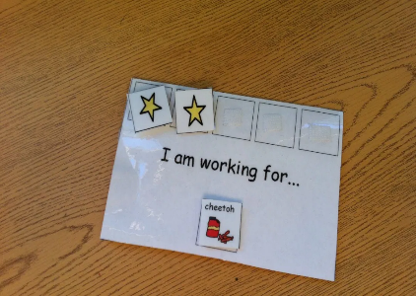
Rewards can be very effective in encouraging work and good behaviour. When first introducing this method you will need to reward more frequently and for very small steps. Rewards will depend on the individual’s motivators EG: Food, iPad, music. Working for / Reward boards are a good visual tool to aid this method of working.

- Simplify and reduce language and give processing time
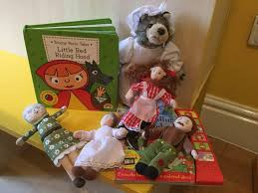
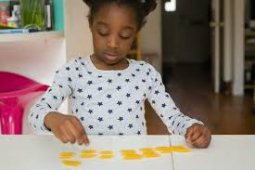
Children with ASD can struggle with verbal communication. Extensive explanations, ambiguous language can cause anxiety as children with ASD generally take longer to hear and process information. Children with ASD can also take things very literally so clear unambiguous language is important. Visuals can help to aid understanding.

- Manage change
Changes in routine can be difficult for children with ASD. Explain any changes in advance if possible using visuals and simple language.
You can help introduce change by adding a change or something different visual to the child’s timetable.

- Take advantage of special interests
Children with ASD often have special interests. If you can incorporate a child’s special interest in to their work you will help achieve their focus and engagement. This can be built into any subject in the curriculum as a ‘way-in’ e.g. A child loves Thomas the Tank Engine;
Maths – Addition (using real toy trains if possible)
+

- Have a safe space
Make a safe space for children to use if they are too anxious or upset. A child must be calm to learn.
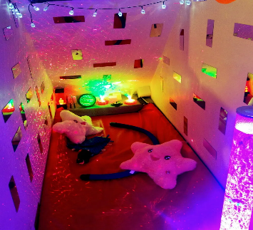
Make it safe and calming and this will speed up their return to the classroom/ workstation space to work. Think about lighting, colour and noise.

