eek 3 home learning activities.

Please explore and enjoy Cbeebies space week. The link has been added above.

Literacy- Our story this week 'Whatever Next' by Jill Murphy. Please see the link below to listen to the story.

Communication & language – To link in with the story ‘Whatever Next’ try to create your own rocket, using a large cardboard box, or if you haven't got one perhaps try a storage box or washing basket. Or make a mini rocket for a teddy (from a cereal box) and pack some things teddy might want to take to the moon.
Playing a game of peek-a-boo with a scarf to encourage joint attention is something else you could practise.
Early Writing - Some activities you could try are: - drawing / painting your own picture of the bear on paper or perhaps you have an I pad with an art app? It can be good fun making marks or copying a picture an adult draws.
Phonics work - See the link (right at the top of this page) to the 'Phonics song' to get you ready for some phonics work.
We have been using the 'Read Write Inc' scheme to practise letter recognition along with letter formations. There is a link below which shows the formation of the letters. Focus on 'm', copying the formation 'saying' from the video 'mmm, Masie mountain mountain'. Now try out the formations in some sand / flour / foam or using some different coloured pens.

Maths- Can we count the stars? 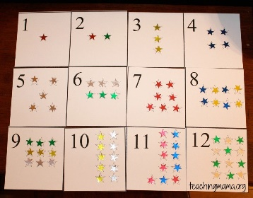 If anybody has any star stickers at home, also great for reward/ treat charts.
- Can we count the falling stars? 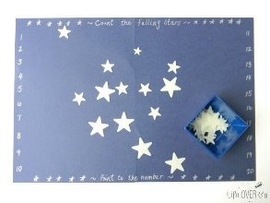 Using cut outs of stars/ stickers. Count as we pour the stars out onto black card/ or any coloured paper.
- Please see below worksheets if you have a printer at home.
- Can we have a teddy bears picnic just like Baby Bear in our story. Counting out the plates/ cups/ food items.

Number – See number song ‘Men in a Flying Saucer’ (Link is above) and practise making the amount on your fingers each time one man flies away. An adult can help write the numerals; can you point to the numbers as you count together. Or clap out the amount together.
Have a look for some things you could count around the house, e.g. teddies, toy trains, plastic cups. Find 2 of each item and hold one up, asking your child ‘Can you find the same?’
Shape - Use the 2D shape song (link at the top of the page) to focus the children on shape work. Have a go at making pictures from shapes. An adult will need some coloured paper or can use the back of a cereal box to cut out some rectangles, squares and triangle shapes. Play the 'find the same' game - holding a shape up and ask your child to find one the 'same'. Or hide the shapes in a sand tray and explore finding the different shapes. Next have a go at making different pictures with the shapes. Can you make a rocket picture?

Topic (Exploring the stars)- All about astronauts.
- Has anybody got a Buzz lightyear at home? What does he look like? What can he do?
- Cbeebies has got some great video clips about astronauts in space (Tim Peake).
- There is a link below for colouring in a astronaut.

Science (materials)- Which materials are strong?
- What materials are our houses made from? Can we build a house? If you have any blocks/ Duplo/ Mega blocks at home can we make design/ build a house or building?
- Please see the link below for the story 'The three little pigs'. Which house was the strongest?
- Can we test materials with a hairdryer at home (on a cool setting with an adult). Which materails blow away? Have we got any string materials at home ( metal pans/ the houses made from blocks). Does anything blow away (a straw/ sticks from outside).

PHSCE/ RSE (Esafety)- please see link above.
Families- Families are all different. Please see link below for video clips with different types of families.
- For this weeks activity (if anybody has any animal toys at home) could we sort the animals into families.

P.E. – Start off having a dance to some favourite music. Or try out the ‘Wake up action song’ (link can be found in the top section of links). If the weather is kind to you see if you can get out and play chase around your garden. Saying ‘ready, steady, go’ will build anticipation as you play.
We will be working on rolling this week in P.E., in particular making a ‘long’ shape and trying out log rolls. Perhaps you make a long shape and try some log rolls at home along the floor.

R.E. – Listen to the starter song ‘This little light of mine’ (link above) as you make light patterns on the wall, ceiling, table with a torch; perhaps your child could help to ‘turn out’ the light and switch ‘on’ the torch with you. Look at the logo for Brookfields and the different classes on the website.
We will be looking at Christian symbols, this week focusing on the cross. Some activities you could try at home are: - painting your own cross, making a cross from playdough, collecting twigs from the garden and creating your own cross.

Exploring technology - There are some space games that you can play on Discovery Education Espresso (you will need your log in, so please do ask if you can't find it). The 'snap' planets and 'counting planets' are games we are focusing on this week. (Links are below.)
If you have a snap cards you could try this at home; or look at the cards along with an adult, matching the ones that are 'the same'. Also you could practise skills of switching toys or a torch 'on'.

We would love to see photos of you busy with your home learning or any pictures you have made.
Keep safe.

