Class: Hawks Term: Spring Term- 2022 (January – April) Explorers & Adventurers
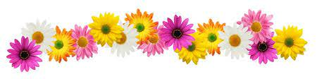
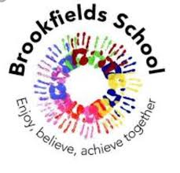
Communication & Language / English – Language & Communication

This term, the Explorers will use environmental sounds and songs to engage themselves and maintain attention. They will share the weekly books with adults, developing their understanding and working on their early comprehension skills. Pupils will also develop speech and language and other communication aids and plans to support their communication
The adventurers will continue their work and continue to develop around the reading and writing skills. They will follow the RWI scheme to develop their phonic knowledge. In addition, the adventurer’s children will be learning to write creatively using descriptive language in Talk4Writing sessions, based around a story.

Read, Write Inc is the scheme of work we will follow to learn our letter sounds and names, word build and support us in learning those ‘tricky words’.

Spring
Thinking & Problem Solving / Maths – Thinking, Problem Solving & Finance

In Thinking and Problem Solving, we will experience number and counting whilst using problem solving skills. We will explore shapes through hands on sensory activities and exploring shapes within our environment. We will increase our thinking and independence skills whilst learning about measurement, such as long and short.

In Maths this term, Adventurers will cover number, size, shape, capacity and time.
We will also develop our teamwork and problem solving skills through PE and cross curricular activities. These skills will also be embedded throughout our curriculum and learning.

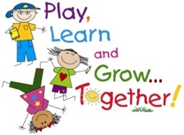
Life Skills – Understanding the World I Live In

This term we will be looking at where we belong as individuals. The part we can play within society to become good citizens and support the looking after of our earth. This will involve aspects of: healthy eating, recycling and our carbon footprints.
My Creativity / Creative Development

This term we will to look at the work of famous Artists as inspiration to become young Artists ourselves: using different malleable materials, painting and drawing to illustrate the beauty of our earth and space.

Musical instruments will be explored - we will explore echoes and sounds in our environment whist learning beyond the classroom. Different rhythms, pitches and patterns will be discovered and investigated whilst listening to different genres and mood contrasts of music.

Construction as a skill will be a big focus of our term as we explore different continuous provision opportunities in our cross-curricular learning, creating Lego rockets and spaceships. We will be evaluating the properties of different materials and identifying those best to build our own rockets.

The children have continued to make fantastic progress last term in Hawks class and have built strong relationships with both their peers and the staff. This term is dedicated to continuing promoting those strong relationships and working together as a team to ensure each child is stretched to their full potential and has lots of fun along the way – promoting cultural capital and positive experiences and making memories!
Learning through play:

This term as part of our ‘Why do we live on Planet Earth?’ topic, we will be using experimental play to dress up and role play astronauts. We will explore lots of objects of reference such as different rockets, glow in the dark stars and moons and lots of other sensory space activities as part of our continuous provision. In addition, we will have access to different space themed Lego where we can demonstrate and practice our design and technology skills. Opportunities to learn through play will occur in other subjects: choose time, extension activities, PE sessions, learning beyond the classroom (Soft play, outside play, tyre park, lightroom).

Myself & My Body / Personal Social & Emotional Development

This term we will be looking at our bodies and how they change as we develop and grow. As part of this we will be looking at what is a healthy diet and how to make the right choices of food to keep our bodies healthy. We will be looking back at how we have changed from being babies throughout the stages of life. Additionally, we will be talking about how we as children moving forwards are going to develop and change again several times throughout our lives. This will be taught through the emotional and bodily changes that we may experience. Our job this term will be to support the children during these changes to develop self-regulation strategies’ and build their understanding. We will cross curricular this with science and reinforce our learning from last term about our skeletons and muscles that help us grow and develop.
Our Adventurers will be expanding their learning by developing their independence skills and building on their personal hygiene. We will discuss the importance of privacy. The main focus for our Adventurers this term is to build their self-confidence and self-esteem as young adults and promote uniqueness.
Our Explorers will be focusing on the sequencing the life cycle to show an awareness that we change and develop as we grow. They will be look at how we as humans can keep healthy and hygienic by practicing and promoting skills such as brushing our teeth, getting washed and dressed. This learning will be done through lots of experimental learning.
Thematic Learning:
My World & My Community / Understanding My World & My Community

Collective Worship is timetabled at the start of each school day. We have an allocated section on our bookshelf where children can freely choose. This term the books within the worship section will explore some of the key elements underpinning our Brookfield’s Curriculum; emotions, friendships, belonging and sharing.

