Creative Curriculum 2018-2019
EYFS and Key Stage 1
Class | Autumn term | Spring Term | Summer Term
Butterflies  (EYFS) | How does my body work? | CBeebies | Why did Jack and Jill go up the hill?
Hedgehogs  (EYFS) | Why did Jack and Jill go up the hill? | CBeebies | What’s my favourite pet?
Squirrels  (Yr 1) | Can I really eat plants?  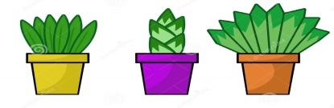 | Why does a builder need a hard hat? | How does milk get into my glass?
Woodpeckers  (Yr2) | What makes me unique (including My senses / The Body)? | 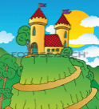  Why is a castle built on a  hill? | Who lives in the forest?
Kingfishers  (Yr2) | What makes me unique (including where I live)? | What is a dolly tub? | 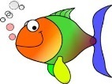  Why can’t I live under the water with the fish?

Creative Curriculum 2018-2019
Key Stage 2
Class | Autumn Term | Spring Term | Summer Term
Seals  (Yr 3) | Where do I live? | Why are Greek temples made from stone? | 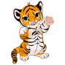  Can tigers live in the arctic?
Hawks  (Yr 4) | And did they live happily ever after? | Why do we live on planet earth? | What will you pack in your suitcase?
Herons  (Yr 4) | And did they live happily ever after? | Why do we live on planet earth? | What will you pack in your suitcase?
Otters  (Yr 5) | 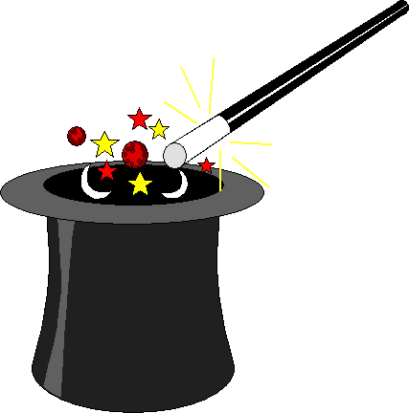  Is magic real? | How much does an elephant eat? | Where does the sea go?
Owls  (Yr 6) | Are you a super scientist? | Who lives in a habitat like this? | Can you cook it?

